READ LIKE AN ANIMAL
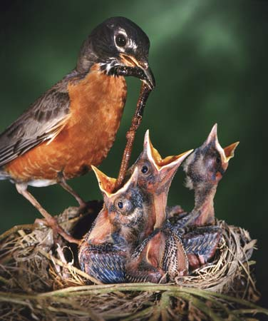
Early Bird Snapshot:
1. You prefer to read small regular portions.
2. You are a person of habit.
3. You like structure, rhythm, and stability.
4. You love the quiet hours in the morning.
5. You learn well visually.

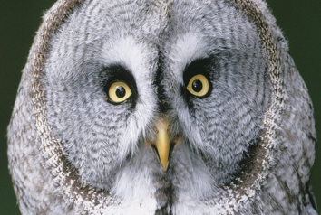
Night Owl Snapshot:
1. You prefer to read small regular portions.
2. You are a person of habit.
3. You may like to play first, work later
4. You get your best work done at night
5. You learn well visually.

Bat Snapshot:
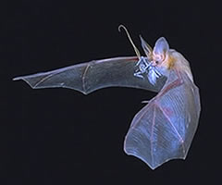
1. You prefer to hear scripture if you can, or read only small sections if not.
2. You learn best by talking about things (external processor).
3. You often have a lot of small, scattered ideas.
4. It helps you to have someone listen to you and bounce back ideas.
5. You need to hear things and say things to understand them.

Cow Snapshot
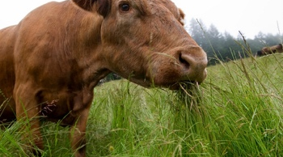
1. You are a slow and steady worker/thinker.
2. You like to think about decisions before acting. Process time is important.
3. You like to read passages and pull out snippets to think about.
4. You like post-it note quotes and sayings.
5. You may be a morning person, diurnal, or nocturnal.

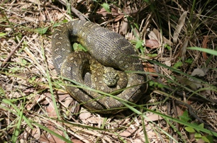
Python Snapshot
1. You work best in planned spurts of activity.
2. You would rather get work done all at once than keep coming back to it later.
3. You like to see the whole picture in order to understand the parts.
4. You may like to live with an idea for a while before acting.
5. You may be a morning person, diurnal, or nocturnal.

Anteater Snapshot
1. You love to chase down answers for problems and questions.
2. Unsolved issues bother you and your mind latches onto them.
3. You have a meaningful questions/doubts regarding faith or doctrine.
4. You like to wrestle with an issue until you figure it out.
5. You work best when inspired, a mood that may come at any time.

